FIFTEEN SHARDS OF LIGHT
Level_03_Art_Production_Bible
Boundary Map • Layer Split • Asset Registry • Blender → GLB → Godot Integration
«После наших разговоров»
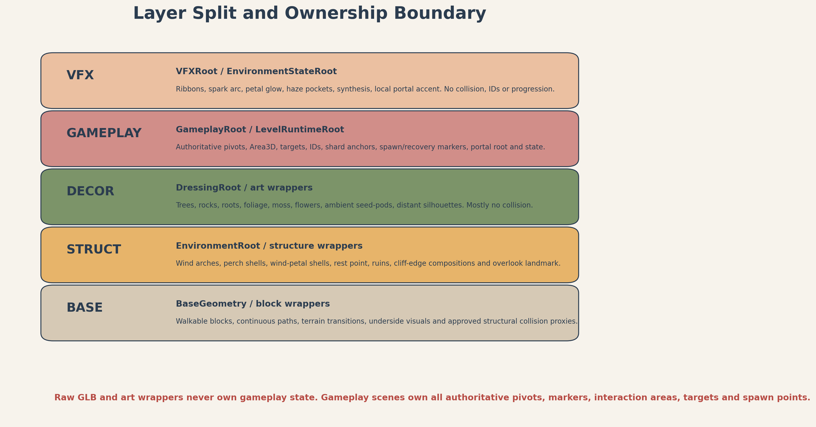
Production-layer overview. The gameplay layer remains authoritative; art layers are replaceable.
Control | Value
Project | Fifteen Shards of Light
Repository | MindDevastation/fifteen-shards-of-light
Target level | Level_03 only / res://scenes/levels/Level_03.tscn
Document status | ART PRODUCTION DESIGN CANDIDATE - Producer approval required
Mode | Documentation only - no Blender files, GLBs, textures, final materials, Godot wrappers, branches or PRs
Authorized next gate | Greybox Development Reference after Producer approval; no Codex implementation or initial runtime PR is authorized by this document

EMOTIONAL SAFETY CONTRACT
The heroine is not broken and is not being repaired. Her light already belongs to her. Environment changes describe the author’s increasing clarity and lightness; they do not create emotional debt, demand an answer, or frame the player as a savior.

0. Document control, source hierarchy and scope

0.1 Four-source authority hierarchy
Priority | Approved source | Authority in this Bible
1 | Level_03_Narrative_and_Level_Scenario_Package.docx | Meaning, emotional safety, exact shard/main texts, narrative order and forbidden readings.
2 | Level_03_Visual_Master_Concept_Package_v1.1.docx | Shape language, visual hierarchy, semi-hero limit, environment-state reading, palette and art-direction guardrails.
3 | Level_03_Gameplay_Map_and_Level_Design_Spec_v1.1.docx | Exact world coordinates, dimensions, route width, puzzle clearances, recovery rules, camera QA points and acceptance constraints.
4 | Level_03_Technical_Architecture_and_State_Model_v1.1.docx | Scene ownership, authoritative gameplay markers/pivots, root-layer split, wrapper boundaries, runtime references and portal/recovery ownership.

Conflict rule
Narrative controls meaning and copy. Visual Master controls art language. Gameplay Spec controls exact coordinates and clearances. Technical Architecture controls ownership and scene boundaries. This Bible defines production decomposition without overriding any of those authorities.

0.2 Current repository snapshot and legacy replacement
Item | Verified snapshot | Production implication
Current Level_03.tscn | SHA 1d8ee50989bbf9d06e8a1fb4f3fe11648b17182b; one LevelManager, one SoulShard, PoemRewardUI, four step platforms, three reveal triggers. | Legacy placeholder only. It does not constrain art decomposition and must not be treated as canonical layout.
AGENTS.md | SHA f0a50cd2710487923f2de649813301a2899a723d; small-slice workflow and no polished assets before a working greybox. | Final art and wrapper integration remain post-greybox.
Shared LevelPortal | Current shared scene owns portal visual, InteractionArea, activation and scene transition. | Level_03 art may provide only a dormant environmental setting and local accent VFX; no custom portal state ownership.

• No repository writes were made while producing this Bible.
• No exact runtime NodePaths, scripts, state machines or scene implementations are created here; the Technical Architecture remains authoritative for those details.
• All proposed art paths and names are production contracts for later approved work, not evidence that files already exist.

0.3 Document map
Section | Purpose
1 | Art production verdict and non-negotiable production rules
2 | Boundary Map and clearances
3 | BASE / STRUCT / DECOR / GAMEPLAY / VFX layer split and node ownership
4 | Coordinate, naming, origin and import contracts
5–6 | Complete asset registry, budgets and LOD rules
7–8 | Material/VFX families and production sheets
9–10 | Collision matrix and pivot/marker contracts
11 | Wrapper-first Blender → GLB → Godot pipeline and primitive replacement
12 | Immediate Greybox Handoff
13–16 | Post-greybox slices, priorities, export checklist and acceptance gates
Appendices | Exact production anchors, path plan and final handoff boundary

1. Art production verdict
VERDICT
APPROVE FOR PRODUCER REVIEW AS AN ART-PRODUCTION DESIGN CANDIDATE. The level can be produced with three semi-hero families, shared modular kits and a wrapper-first integration pipeline. No final art may enter the initial greybox PR. The exact S-route, safe clearances, gameplay-owned markers and shared portal contract remain unchanged.

1.1 Locked production principles
• One continuous asymmetrical S-route. Art must never turn the level into a circular hub, arena, shrine or challenge bowl.
• Exactly three semi-hero visual families: Wind_Arch_Family, SeedPod_Perch_Family and Wind_Petal_Family.
• Final Overlook, ruin clusters and Rest Point are compositions from modular kits, not additional hero families.
• Gameplay scenes exclusively own authoritative pivots, interaction areas, IDs, targets, shard anchors, spawn/recovery markers and portal root.
• Raw GLB and art wrappers own only presentation: meshes, approved static collision, materials, presentation-only animation and non-authoritative ArtAlignment_* markers.
• No imported node name may become a critical gameplay dependency. Art swap must not change the Level_03 gameplay API.
• Positive scale only. A required mirror is applied in Blender and exported as an explicit variant.
• The world is visibly alive and colored in E0. Production cannot rely on a dead/grayscale base asset set.

2. Boundary Map
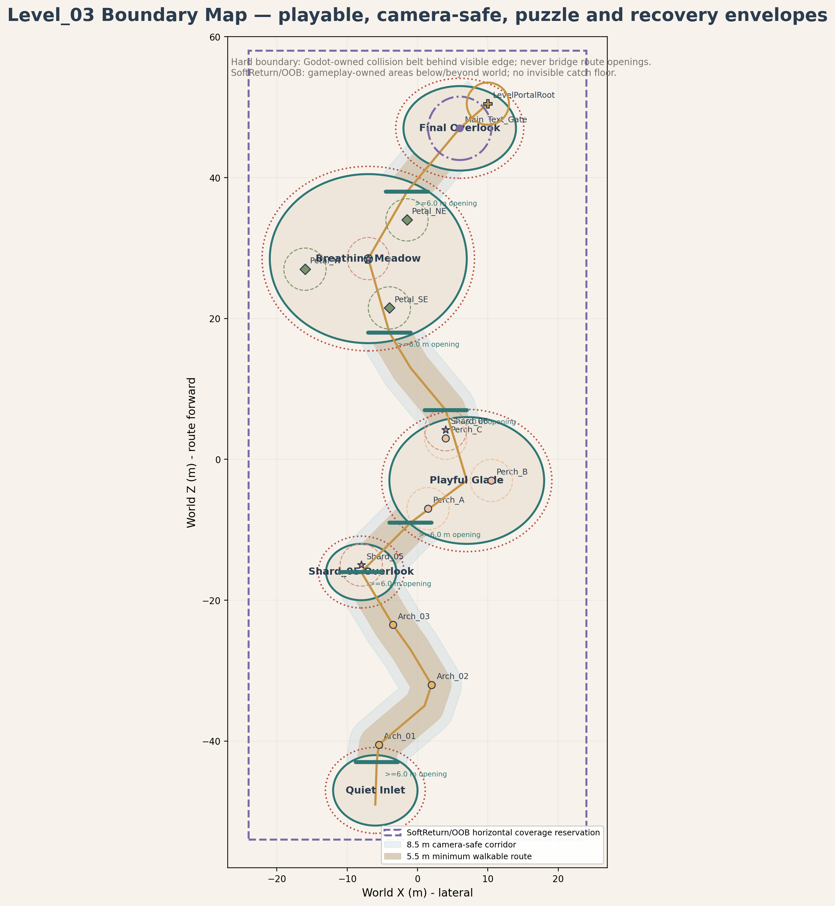
Figure 1. Boundary Map: playable surfaces, hard boundary belt, camera-safe corridor, puzzle clearances, recovery anchors and portal clearance.

2.1 Boundary classes
Boundary | Location | Size / range | Physical form | Owner | Production rule
Playable surface | All mandatory route and zone floors | 44 × 106 m world envelope; zone footprints per Gameplay Spec | Visible floor + walkable collision | BASE art / Godot block wrapper | Continuous; no gaps >0.10 m; cross-slope <=3°.
Mandatory route corridor | P00–P16 S-route | 5.5 m minimum; 6–7 m at turns, entrances and reward areas | Visible floor | BASE / gameplay design authority | No dense decor or blockers.
Route shoulder | Both sides of mandatory route | 1.5 m minimum beyond walkable edge | Visible, mostly non-walkable dressing buffer | DECOR / Art | Keep free of dense props and camera blockers.
Camera-safe corridor | Around mandatory centerline | 8.5 m total clear corridor | Not visible | Art placement rule | Tall props outside; low plants allowed if silhouette remains clean.
Hard boundary belt | Behind natural cliff/edge composition | 1.0–1.5 m thick; placed behind visual rim | Invisible blocker, supported by visible edge | GAMEPLAY collision / STRUCT visual edge | Never crosses route mouths, reward clearances or camera corridor.
Soft visual boundary | Cliff shelves, rocks, roots, low ruins, foliage | Variable; outside shoulder | Visible, primarily non-colliding | STRUCT + DECOR | Reads as natural edge, never as fortress wall.
SoftReturn envelope | Below playable world | One broad explicit Area3D below level | Invisible Area3D | GAMEPLAY / SafetyRoot | No invisible catch floor. Recovery only after entering explicit volume.
Explicit OOB volumes | Known side escape risks only | Authored per location after greybox playtest | Invisible Area3D | GAMEPLAY / SafetyRoot | Must not overlap legal side spaces or overlooks.
Puzzle clearance | Shard/perch/petal centers | 3.0 m clear radius | Not visible | GAMEPLAY authority; Art exclusion zone | No tall props or camera-blocking vertical forms.
Portal clearance | LevelPortalRoot at (10,1.6,50.5) | Minimum 4.5 m clear radius around shared portal footprint | Visible clean floor + shared trigger | GAMEPLAY shared portal / BASE art floor | No overlook prop, landmark arch or local accent may intersect shared InteractionArea.
Decor-only zone | Outside route shoulder and puzzle clearances | Within art envelope and sightline guardrails | Visible | DECOR | No gameplay reliance; removable without progression impact.
No-decoration corridors | Route mouths, arch openings, reward lines, CP0–CP4 sightlines | Per map and QA views | Not visible | Art placement rule | No tall/busy prop that hides next landmark or target.

2.2 Zone boundary schedule
Zone | Locked footprint | Route openings | Critical clearance | Recovery
Block_03_00 Quiet Inlet | Center (-6,0,-47), 12×10 m oval | 1 broad opening toward P01; no closed rear wall that traps camera | Spawn clear 4 m; CP0 line to Final Overlook preserved | RA0
Block_03_01 Wind Trace | P01–P06, floor Y 0.08–0.80 | Route continuously open through all three arches | Arch internal W >=6.5 m; overhead >=5.2 m | RA1 after route milestone
Block_03_02 Shard05 Overlook | Center (-8,0.9,-16), 10×8 m oval | At least 6 m route opening to glade approach | Shard >=2.5 m from edge; 3 m clear radius | RA2
Block_03_03 Playful Glade | Center (7,1,-3), 22×18 m oval | Entry at P08 and exit at P10 remain broad and obvious | Perch A/B/C each 3 m clear radius; one camera composition | RA3
Block_03_04 Connector | P10–P12, W 5.5–6 m | No new gameplay gate; both ends fully open | Reduced prop density; meadow readable before entry | RA4 at meadow entry
Block_03_05 Breathing Meadow | Center (-7,1.3,28.5), 28×24 m oval | Entry/exit openings remain visually distinct, not ring walls | 3 m around each petal and Rest Point; all targets visible from P12 | RA5
Block_03_06 Final Overlook | Center (6,1.6,47), 16×12 m oval | Approach from P14; horizon remains open | Main_Text_Gate R4.5; portal clear R4.5; CP4 framing preserved | RA6

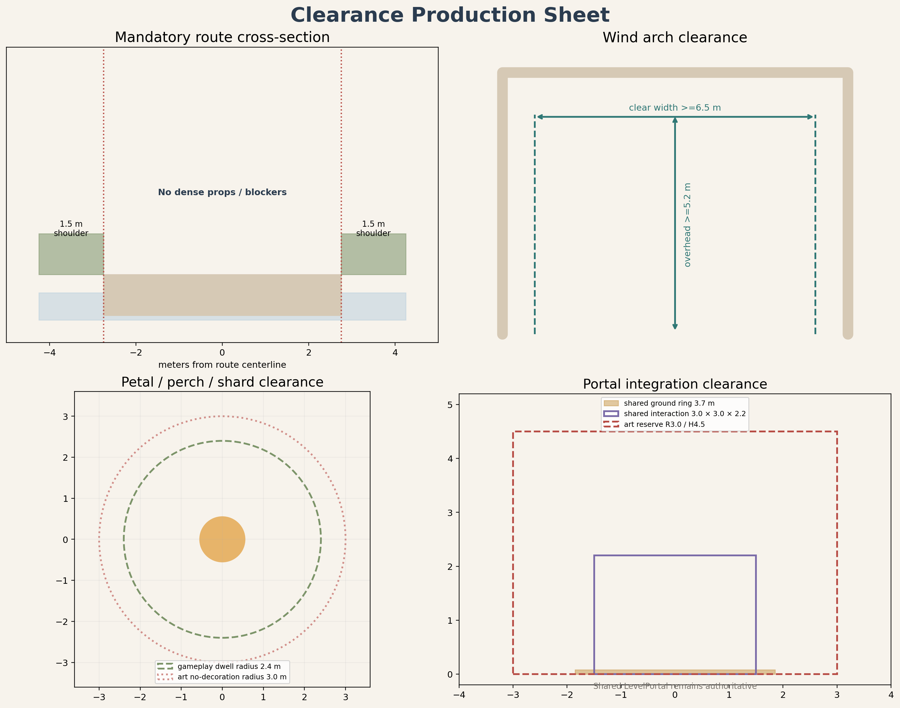
Figure 2. Cross-sections and clearance rules. Hard blockers sit behind natural edges; SoftReturn remains the only broad fall-recovery authority.
NO INVISIBLE CATCH FLOOR
Optional underside collision may exist only directly beneath visible walkable geometry to prevent tunneling. It may not bridge visual gaps, extend playable space, or prevent the player from reaching SoftReturnVolume.

3. Layer split and node ownership

Figure 3. Production layer split. Gameplay authority is isolated from replaceable art and VFX.
Layer | Contains | Scene owner | Explicitly must not own
BASE | Terrain/platform floors, route modules, ground transitions, visible undersides, basic elevation and approved structural walkable collision. | EnvironmentRoot/BaseGeometry and block wrappers | World layout, routes, triggers, IDs, progression, puzzle state.
STRUCT | Wind arches, perch bases, wind-petal shells, ruin modules, cliff-edge modules, shard platforms, Rest Point dais and Final Overlook modular composition. | EnvironmentRoot/LandmarkRoot or block wrappers | Authoritative rotation/petal pivots, landing targets, portal root, interaction areas.
DECOR | Rocks, roots, trees, bushes, grass, flowers, moss, hanging vines, distant silhouettes and non-blocking ruins. | EnvironmentRoot/DressingRoot or art-only children of wrappers | Any gameplay state or required navigation dependency.
GAMEPLAY | Area3D, CollisionShape3D for interactions, canonical IDs, gameplay controllers, ShardAnchor, LandingMarker, PetalPivot, targets, spawn/recovery markers, Main_Text_Gate, LevelPortalRoot. | GameplayRoot, PlayerRoot, MarkerRoot, SafetyRoot | Raw GLB hierarchy and art wrappers.
VFX | Wind ribbons, grass response, abstract spark impulse, preglow, local haze, mote trails, synthesis and local portal accent. | VFXRoot / EnvironmentStateRoot | Collision, puzzle completion, shard state, main text, portal activation or recovery.

3.1 Authoritative ownership matrix
Concern | Authoritative owner | Art boundary
Walkable floor shape and visual surface | BASE block wrapper | Gameplay Spec dimensions; art may not narrow it.
Hard boundary collision belt | Gameplay block/Safety-owned collision nodes | STRUCT/DECOR only provide visible edge reading.
Arch crossing trigger and Arch ID | WindTrace gameplay scene | Wind arch GLB/wrapper has no trigger or ID.
RibbonOrigin / NextTarget marker | WindTrace gameplay scene | Wrapper may contain ArtAlignment_Ribbon only for presentation alignment.
Spark approach Area3D, sequence target and LandingMarker | PlayfulSpark gameplay scene | Perch GLB contains no approach radius or sequence order.
Petal dwell Area3D and authoritative PetalPivot | BreathingMeadow gameplay scene | Petal GLB owns attachment origin only.
Shard spawn/reveal anchor | Level03ShardSlot gameplay scene | Shard platform is visual support only.
Rest Point progress facts and ConvergenceMarker | BreathingMeadow gameplay scene | Dais/segments display state but do not compute it.
Main text gate | FinalOverlook gameplay scene | Final Overlook art composition does not own player presence.
Portal activation, interaction and scene loading | Shared LevelPortal | Level_03 local art owns only dormant setting and accent VFX.
Soft return, OOB volumes and recovery anchors | SafetyRoot / Level03RecoveryController | No GLB or art wrapper teleports player.

4. Blender, GLB and Godot coordinate / naming contract

4.1 Coordinate conventions
Stage | Locked convention | Verification
Blender source | 1 Blender unit = 1 meter; +Z up; project-authored asset forward = -Y. Apply location/rotation/scale before export. | Scene unit scale 1.0; transforms read 0 / 0 / 0 and 1 / 1 / 1 after apply; no manual axis baking to imitate Godot.
glTF / GLB export | Standard glTF 2.0 export. Positive scale only. No hidden unused objects. Explicit variants for real mirrors. | Export selected production collection; re-open GLB in clean Blender file if orientation is uncertain.
Godot import | Standard glTF conversion: +Y up, -Z forward for imported asset-local convention. | Test import scene confirms scale, local forward, ground contact, origin and material slot mapping.
Level world | Level route advances in world +Z from Quiet Inlet toward Final Overlook. | Do not confuse level-world +Z progression with asset-local authored forward.

Scale and mirroring rule
All placed instances use positive scale. Negative X/Y/Z scale is forbidden. If asymmetrical mirrored geometry is required, apply the mirror modifier in Blender and export a named explicit variant.

4.2 Canonical naming
Element | Pattern | Example
Raw art asset | L03_<Family>_<Element>_<Variant> | L03_WindArch_Frame_A
Optional collision export | L03_<Name>_<Variant>_COL | L03_WindArch_Frame_A_COL
Godot art wrapper | same canonical asset name | L03_WindArch_Frame_A.tscn
Block wrapper | Block_03_<index>_<Zone> | Block_03_03_PlayfulGlade.tscn
Material | M_L03_<Family> | M_L03_Stone_Warm
VFX scene / logical family | L03_<Beat>_<Effect>_VFX | L03_WindTrace_Ribbon_VFX
Non-authoritative art marker | ArtAlignment_<Purpose> | ArtAlignment_PetalAttach

4.3 Proposed production paths
Purpose | Proposed path
Blender source | art/blender/level_03/<category>/L03_<Name>_<Variant>.blend
Raw GLB | assets/levels/level_03/<category>/L03_<Name>_<Variant>.glb
Optional custom collision GLB | assets/levels/level_03/<category>/L03_<Name>_<Variant>_COL.glb
Godot wrapper | scenes/environment/level_03/<category>/L03_<Name>_<Variant>.tscn
Level block wrapper | scenes/levels/level_03/blocks/Block_03_0X_<Zone>.tscn
Level-local VFX scene | scenes/levels/level_03/vfx/L03_<Beat>_<Effect>_VFX.tscn

These paths are proposed production contracts. They do not claim that the folders or files currently exist.

5. Complete asset registry
Registry status: design candidate. Dimensions are production targets derived from the approved gameplay clearances and visual hierarchy. Exact decorative micro-variation remains an art decision as long as gameplay and camera gates pass.

5.1 BASE registry
Canonical asset | Purpose / dimensions | Origin / pivot contract | Variants | Material / emission | Collision | Triangle / LOD target | Proposed paths | Priority
L03_Block_QuietInlet_Base_A | Spawn shelf, 12×10×0.7 m oval | Zone center at floor Y=0; origin ground-center | A | Stone / soil / moss; no emission | Simplified custom walkable collision | 6–14k; LOD1 if >10k | .../base/L03_Block_QuietInlet_Base_A.{blend,glb,tscn} | P0/P2
L03_Block_Shard05Overlook_Base_A | Reward shelf, 10×8×0.7 m oval | Zone center ground; route seam oriented to P07 | A | Stone / soil / moss | Simplified custom; continuous floor | 5–12k; optional LOD1 | .../base/L03_Block_Shard05Overlook_Base_A.* | P0/P2
L03_Block_PlayfulGlade_Base_A | Oval glade, 22×18×0.8 m | Zone center ground at P09 | A | Stone path + soft soil + moss | Simplified custom; no cracks | 8–18k; LOD1 recommended | .../base/L03_Block_PlayfulGlade_Base_A.* | P0/P2
L03_Block_BreathingMeadow_Base_A | Open meadow, 28×24×0.9 m | Zone center ground at P13 | A | Soil, moss/grass, stone inserts | Simplified custom; <3° puzzle floor | 10–20k; LOD1 recommended | .../base/L03_Block_BreathingMeadow_Base_A.* | P0/P2
L03_Block_FinalOverlook_Base_A | Final vista floor, 16×12×0.8 m | Zone center ground at P15; portal floor kept clean | A | Warm stone + soil + restrained accent | Simplified custom; portal area continuous | 7–15k; LOD1 if needed | .../base/L03_Block_FinalOverlook_Base_A.* | P0/P2
L03_Path_Module_Straight_A | Straight route module, 6×5.5×0.5 m | Center of lower seam / ground plane | A/B length variants | Stone path + soil border | Simple custom or box blend | 2–5k; no LOD normally | .../base/L03_Path_Module_Straight_A.* | P0/P2
L03_Path_Module_Curve_Gentle_A | Curved route, arc R8–12 m, W5.5 m | Arc chord center; documented tangent | A/B left/right explicit | Stone path + soil border | Simple custom continuous collision | 3–7k; no LOD normally | .../base/L03_Path_Module_Curve_Gentle_A.* | P0/P2
L03_Path_Module_Ramp_A | 8×5.5 m, rise <=0.4 m | Lower seam center; local forward uphill | A/B rise variants | Stone path + soil border | Simple custom; slope <=8° preferred | 3–7k; no LOD normally | .../base/L03_Path_Module_Ramp_A.* | P0/P2
L03_Path_Transition_Cap_A | 3×5.5×0.5 m zone-to-path blend | Seam center at floor | A/B | Stone/soil/moss blend | Simple custom | 1–4k; none | .../base/L03_Path_Transition_Cap_A.* | P0/P2
L03_Path_Edge_A | 3×0.8×0.8 m soft edge trim | Inner walkable seam center | A/B/C | Stone/moss | No collision or simple strip | 0.8–2.5k; none | .../base/L03_Path_Edge_A.* | P2
L03_CliffEdge_Module_A | 4×1.2×1.5 m visible rim | Inner top seam center | A/B | Stone/moss | Visual only; hard belt separate | 2–6k; LOD1 optional | .../base/L03_CliffEdge_Module_A.* | P2
L03_Block_Underside_Trim_A | 4×2×1 m underside dressing | Top inner seam | A/B | Stone/soil | No catch-floor collision | 1–4k; LOD1 optional | .../base/L03_Block_Underside_Trim_A.* | P3

5.2 STRUCT registry
Canonical asset | Purpose / dimensions | Origin / pivot contract | Variants | Material / emission | Collision | Triangle / LOD target | Proposed paths | Priority
L03_WindArch_Frame_A | Semi-hero broad arch, 8.0×1.2×6.2 m; clear W >=6.5 m, H >=5.2 m | Floor-center between supports; local forward -Z after import | A | Stone_Warm + WindRibbon_Emissive insert | Optional support convex only; trigger separate | 8–15k; LOD1 | .../struct/L03_WindArch_Frame_A.* | P1
L03_WindArch_Frame_B | Asymmetrical family variant, 8.4×1.3×6.0 m | Same contract as A | B explicit, positive scale | Same shared slots | Optional support convex only | 8–15k; LOD1 | .../struct/L03_WindArch_Frame_B.* | P2
L03_WindArch_EmissionInsert_A | Separable ribbon groove/inlay, approx 6.8×0.1×5.5 m | Matches arch floor-center | A/B fit variants | WindRibbon_Emissive; maskable | None | 0.5–2k; none | .../struct/L03_WindArch_EmissionInsert_A.* | P1
L03_SeedPod_Perch_Base_A | Perch support, 1.6×1.6×0.7 m | Base bottom-center | A/B height variants | Stone_Warm / moss | Prefer none; low convex if needed | 2–4k; none | .../struct/L03_SeedPod_Perch_Base_A.* | P1
L03_SeedPod_Cluster_A | Primary reactive cluster, 1.4×1.2×1.0 m | Bottom-center attachment | A | SeedPod_Emissive + foliage | No physical collision | 2–5k; LOD1 optional | .../struct/L03_SeedPod_Cluster_A.* | P1
L03_SeedPod_Cluster_B | Explicit silhouette variant, 1.2×1×0.9 m | Bottom-center attachment | B | Shared family materials | No collision | 2–5k; LOD1 optional | .../struct/L03_SeedPod_Cluster_B.* | P2
L03_WindPetal_Base_A | Petal pedestal/socket, 1×1×0.35 m | Ground center | A | Stone_Warm + small emission insert | None or tiny simple base collision | 1–3k; none | .../struct/L03_WindPetal_Base_A.* | P1
L03_WindPetal_Leaf_A | Controllable visual leaf, 1.2×0.35×1.8 m | Physical attachment point; not authoritative gameplay pivot | A | Petal_Translucent + emission mask | No collision | 3–6k; LOD1 optional | .../struct/L03_WindPetal_Leaf_A.* | P1
L03_WindPetal_Leaf_B | Applied mirror / asymmetry variant, 1.15×0.4×1.7 m | Same attachment contract | B explicit; no negative scale | Shared family materials | No collision | 3–6k; LOD1 optional | .../struct/L03_WindPetal_Leaf_B.* | P2
L03_RestPoint_Dais_A | Calm center, Ø3.2×0.35 m | Center ground at Rest_Point | A | Stone_Warm + RestPoint emission | Simple low cylinder/custom | 2–5k; none | .../struct/L03_RestPoint_Dais_A.* | P1
L03_RestPoint_Segment_A | One of three emissive arc inserts | Dais center; rotations use positive scale | One mesh, 3 rotated instances | RestPoint_Emissive | None | 0.2–1k; none | .../struct/L03_RestPoint_Segment_A.* | P1
L03_Shard_Platform_A | Small visual support, Ø1.6×0.25 m | Center ground under gameplay ShardAnchor | A/B dressing variants | Stone / restrained glow insert | Simple low cylinder or none | 1–3k; none | .../struct/L03_Shard_Platform_A.* | P1
L03_RuinArch_Half_A | Modular soft ruin, 3.5×1×4.5 m | Ground center; authored -Y forward | A/B explicit | Stone_Warm / moss | Simple boxes/convex only if near player | 3–8k; LOD1 | .../struct/L03_RuinArch_Half_A.* | P2
L03_RuinColumn_Low_A | Low column, Ø0.8×2 m | Bottom-center | A/B/C cap variants | Stone_Warm / moss | Simple capsule if required | 1.5–4k; optional LOD1 | .../struct/L03_RuinColumn_Low_A.* | P2
L03_RuinWall_Stump_A | Low wall fragment, 3×0.8×1.8 m | Bottom-center, inner face documented | A/B | Stone_Warm / moss | Simple box/convex if blocking | 2–6k; LOD1 optional | .../struct/L03_RuinWall_Stump_A.* | P2
L03_FinalOverlook_Composition_A | Godot wrapper composition from path/ruin/cliff/glow kits; no unique hero GLB | Wrapper origin at Final Overlook center; portal root remains external | Composition variants only | Shared modular materials | Uses component collisions only | No unique triangle budget | scenes/environment/level_03/compositions/L03_FinalOverlook_Composition_A.tscn | P2

5.3 DECOR registry
Canonical asset | Purpose / dimensions | Origin / pivot contract | Variants | Material / emission | Collision | Triangle / LOD target | Proposed paths | Priority
L03_BoundaryRock_Set_A | Boundary framing rocks, 0.5–2.5 m | Bottom-center per piece | 6–10 pieces | Stone_Warm / moss | No collision except selected large pieces | 300–3k each; atlas; cull/LOD | .../decor/L03_BoundaryRock_Set_A.* | P2
L03_Root_Cluster_A | Soft edge/root framing, 1–4 m | Attachment / bottom center | A/B/C | Bark_Root | None | 0.8–3k; optional LOD1 | .../decor/L03_Root_Cluster_A.* | P3
L03_Tree_Silhouette_A | Major tree, 4–7 m crown | Trunk bottom center | A | Bark + Foliage atlas | Simple trunk capsule only when needed | 2–8k; LOD1/LOD2 | .../decor/L03_Tree_Silhouette_A.* | P2
L03_Tree_Silhouette_B | Asymmetrical major tree variant | Trunk bottom center | B explicit | Shared family | Simple trunk capsule only when needed | 2–8k; LOD1/LOD2 | .../decor/L03_Tree_Silhouette_B.* | P2
L03_Bush_Cluster_A | Low route-edge bushes, 0.5–1.2 m | Bottom center | A/B/C | Foliage atlas | None | 150–1200; cull | .../decor/L03_Bush_Cluster_A.* | P3
L03_Grass_Tuft_Set_A | Grass tufts and grouped response patches | Bottom center / patch center | 6–12 tufts | Foliage atlas | None | 50–500 each; cull | .../decor/L03_Grass_Tuft_Set_A.* | P3
L03_Flower_Cluster_A | Small warm flowers, <0.6 m | Patch center | A/B/C | Foliage atlas | None | 50–500; cull | .../decor/L03_Flower_Cluster_A.* | P3
L03_HangingVine_A | Hanging vine strip, 1–3 m | Top attachment | A/B | Foliage atlas | None | 100–900; cull | .../decor/L03_HangingVine_A.* | P3
L03_Moss_Patch_A | Ground/stone overlay patch | Patch center | A/B/C | Moss_Grass | None | 50–600; cull | .../decor/L03_Moss_Patch_A.* | P3
L03_SeedPod_Ambient_Set_A | Non-gameplay seed-pod accents | Bottom center | 4–8 pieces | SeedPod_Emissive | None | 100–900; cull | .../decor/L03_SeedPod_Ambient_Set_A.* | P3
L03_DistantIsland_Silhouette_A | Background floating island / shelf | Composition origin | A/B | Distant_Silhouette | None | 0.5–3k; aggressive LOD/cull | .../background/L03_DistantIsland_Silhouette_A.* | P3
L03_DistantRuin_Silhouette_A | Background ruin silhouette | Ground center | A/B | Distant_Silhouette | None | 0.5–3k; aggressive LOD/cull | .../background/L03_DistantRuin_Silhouette_A.* | P3

5.4 VFX logical registry
Canonical asset | Purpose / dimensions | Origin / pivot contract | Variants | Material / emission | Collision | Triangle / LOD target | Proposed paths | Priority
L03_WindTrace_Ribbon_VFX | Arch ripple and current→next guidance; no collision/state | Gameplay RibbonOrigin / NextTarget | 3 bindings | WindRibbon_Emissive | None | GPU/mesh budget validated at 60 FPS | scenes/levels/level_03/vfx/L03_WindTrace_Ribbon_VFX.tscn | P1
L03_WindTrace_GrassResponse_VFX | Grouped grass wave | Gameplay or block ArtAlignment patch only | Reusable | Foliage + animation | None | Small localized response | .../vfx/L03_WindTrace_GrassResponse_VFX.tscn | P2
L03_PlayfulSpark_Impulse_VFX | Abstract warm light impulse; no mascot body | Gameplay SparkVisualRoot / LandingMarkers | One | SeedPod/ivory emission | None | Short trail, bounded particles | .../vfx/L03_PlayfulSpark_Impulse_VFX.tscn | P1
L03_Perch_Preglow_VFX | Current destination preglow | Gameplay perch VisualRoot | Reusable | SeedPod_Emissive | None | Local light/mesh only | .../vfx/L03_Perch_Preglow_VFX.tscn | P1
L03_Petal_Preglow_VFX | Inactive target readability / hint | Gameplay petal VisualRoot | Reusable | Petal_Translucent | None | Local light/mesh only | .../vfx/L03_Petal_Preglow_VFX.tscn | P1
L03_LocalHaze_W_VFX | Local haze channel for Petal_W | EnvironmentStateRoot binding | W | Fog support | None | Bounded volume | .../vfx/L03_LocalHaze_W_VFX.tscn | P2
L03_LocalHaze_SE_VFX | Local haze channel for Petal_SE | EnvironmentStateRoot binding | SE | Fog support | None | Bounded volume | .../vfx/L03_LocalHaze_SE_VFX.tscn | P2
L03_LocalHaze_NE_VFX | Local haze channel for Petal_NE | EnvironmentStateRoot binding | NE | Fog support | None | Bounded volume | .../vfx/L03_LocalHaze_NE_VFX.tscn | P2
L03_SynthesisTrail_VFX | Ripple + spark + petal motifs converge after Shard_07 | Gameplay ConvergenceMarker / VFXRoot | One | Shared emissive families | None | 1.5–2 s bounded presentation | .../vfx/L03_SynthesisTrail_VFX.tscn | P2
L03_PortalAccent_VFX | Level-local calm accent after main text | Shared LevelPortal root external binding | One | M_L03_PortalAccent only | None | Must not duplicate shared portal | .../vfx/L03_PortalAccent_VFX.tscn | P2

6. Asset budgets, LOD and material-slot guardrails
Class | Triangle guidance | Texture guidance | Material slots | LOD / collision guidance
Large BASE block | 6k–20k per independently swappable zone block | Shared tiling 1K–2K sets; no unique 4K | 2–4 maximum | LOD1 when silhouette/distance justifies. Simplified custom walkable collision.
Semi-hero Wind Arch | 8k–15k | Shared 2K family set where justified | 2–3 | LOD1 required. Optional simple support collision; trigger gameplay-owned.
Semi-hero Perch / SeedPod | 2k–5k per component | Shared 1K–2K family | 1–2 | LOD1 optional. Prefer no collision.
Semi-hero Wind Petal | 1k–6k per component | Shared 1K–2K family | 1–2 | LOD1 optional. No collision; gameplay area/pivot external.
Medium ruin / cliff module | 2k–8k | 1K–2K shared stone | 1–2 | LOD1 for tall/distant pieces. Simple box/convex only when needed.
Small prop | 200–3k | 512–1K atlas/shared set | 1 | No collision unless gameplay relevant.
Foliage | 50–1.5k | Shared atlas | 1 | Culling/LOD preferred; no small foliage collision.
Distant silhouette | 0.5–3k | 512–1K / flat shared material | 1 | Aggressive LOD/cull; no collision.

• Budgets are upper planning bands, not targets to fill. Silhouette and gameplay readability outrank density.
• No 4K textures in the initial production plan. A later exception requires explicit visual justification and memory review.
• No monolithic Level_03 GLB. Every block/family remains independently replaceable and testable.

7. Material and VFX family plan
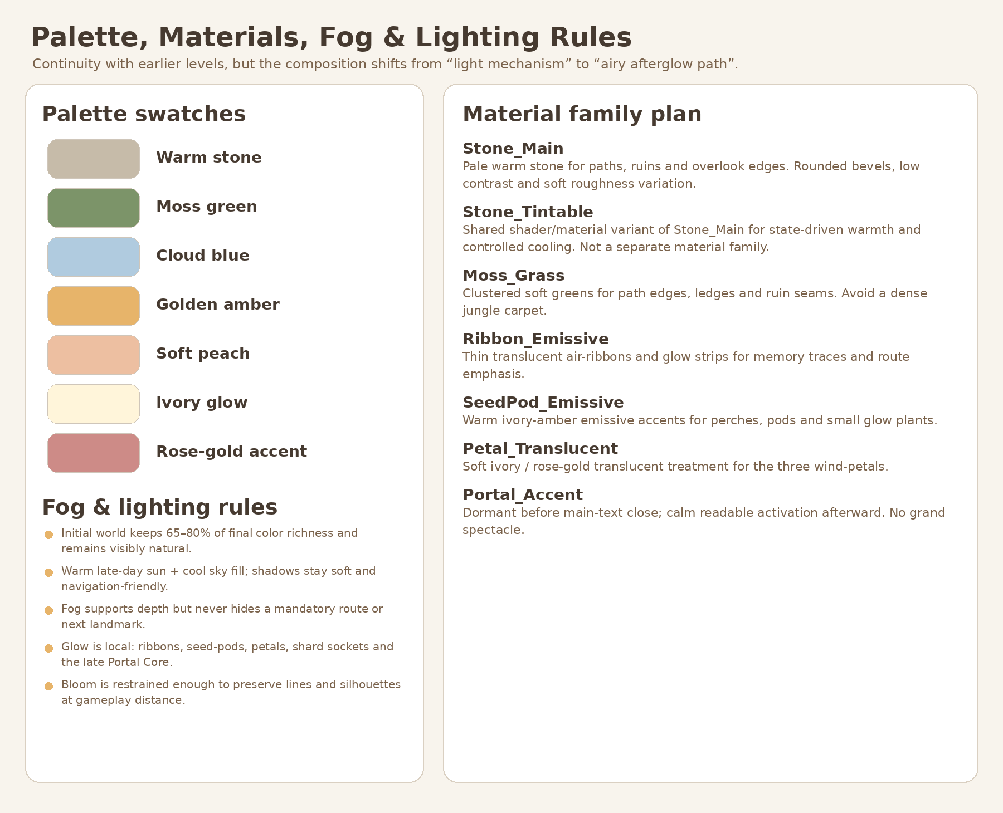
Figure 4. Approved palette/material direction from Visual Master v1.1. Text and tables in this Bible remain production authority.
Family | Layer | Maps | Production rule
M_L03_Stone_Warm | BASE/STRUCT | BaseColor, Normal, Roughness, optional AO | Primary warm ancient stone; matte, low-noise, no baked final lighting.
M_L03_Stone_Tintable | BASE/STRUCT shared shader variant | Same maps + controlled tint/saturation parameters | Variant of Stone_Warm, not a separate texture family. Supports E0–E5 without shared-resource mutation.
M_L03_Soil_Path | BASE | BaseColor, Normal, Roughness, optional AO | Soft route/soil transition; avoids hard tiled path edges.
M_L03_Moss_Grass | BASE/DECOR | BaseColor, Normal, Roughness, optional AO | Moss and low grass; shared atlas/tiling preferred.
M_L03_Bark_Root | DECOR | BaseColor, Normal, Roughness | Trees and root clusters; muted, not dark-horror bark.
M_L03_Foliage_Atlas | DECOR | BaseColor+alpha, Normal optional, Roughness | Shared trees/bush/grass/flowers. Avoid complex transparency on large surfaces.
M_L03_WindRibbon_Emissive | STRUCT/VFX | BaseColor or gradient + emission mask | Warm amber/ivory, separable and controllable; must remain readable without heavy bloom.
M_L03_SeedPod_Emissive | STRUCT/DECOR/VFX | BaseColor + emission mask | Warm impulse/perch family. No face/eyes/mascot appearance.
M_L03_Petal_Translucent | STRUCT/VFX | BaseColor, Normal optional, Roughness, emission mask | Soft ivory/peach/rose-gold; restrained transparency.
M_L03_RestPoint_Emissive | STRUCT/VFX | BaseColor + emission mask | Three readable segments; display-only, no state ownership.
M_L03_Distant_Silhouette | BACKGROUND | BaseColor/Roughness minimal | Low-frequency distant layers compatible with haze.
M_L03_PortalAccent | VFX only | Emission/gradient as needed | Level-local accent only. Shared LevelPortal keeps its own materials and activation state.

7.1 Environment-state compatibility
Phase | Art requirement
E0 Initial | Natural stone/green/cloud-blue visible; richness approx. 65–80% of final. No grayscale/dead material variants.
E1 After Shard_05 | Tintable stone/grass/ribbons support a 4–5 s non-blocking clarity increase.
E2 After Shard_06 | Warm motes and clearer midground without global flash or material swap.
E3 / E4 Meadow progress | Local haze and Rest Point segment changes remain independently controllable.
E5 After Shard_07 / Synthesis | Full warm state and converging motifs; portal remains dormant.
E6 After main text | Only local calm portal accent plus shared LevelPortal activation. No grand spectacle.

8. Production sheets

8.1 BASE blocks and route kit
• Each zone is an independently swappable block wrapper. Block placement follows approved coordinates; final mesh silhouette may vary within art tolerance only.
• Route seams are explicit and documented. Walkable collision continuity is validated before any decor pass.
• Visible edge modules and hard blockers are separate. The art rim may be edited without moving the authoritative boundary belt.
• Underside trim is visual only and never becomes a catch floor across empty space.
Block | Art composition | Required protected spaces
Quiet Inlet | Low shelf, gentle framing tree/ruin, first arch silhouette, open long view | Spawn, 5.5 m route, CP0 sightline, RA0 clearance
Wind Trace Route | Three arch placements, light grass response patches, restrained cliff edges | 6.5 m arch openings, 5.2 m overhead, continuous walkable floor
Shard05 Overlook | Small open pause with low edge composition | Shard 3 m radius, >=2.5 m edge distance, preview to glade
Playful Glade | Oval, asymmetrical low ruin/seed-pod frame | All three perch clearances and one camera composition
Connector | Reduced prop density and cleaner horizon | 5.5–6 m route, no false target
Breathing Meadow | Broad open center, 3 petal compositions, low perimeter | All petals visible from entry; 3 m clear radii; Rest Point center
Final Overlook | Modular horizon frame and dormant portal setting | Main gate R4.5, portal R4.5, horizon and CP4 line

8.2 Wind_Arch_Family production sheet
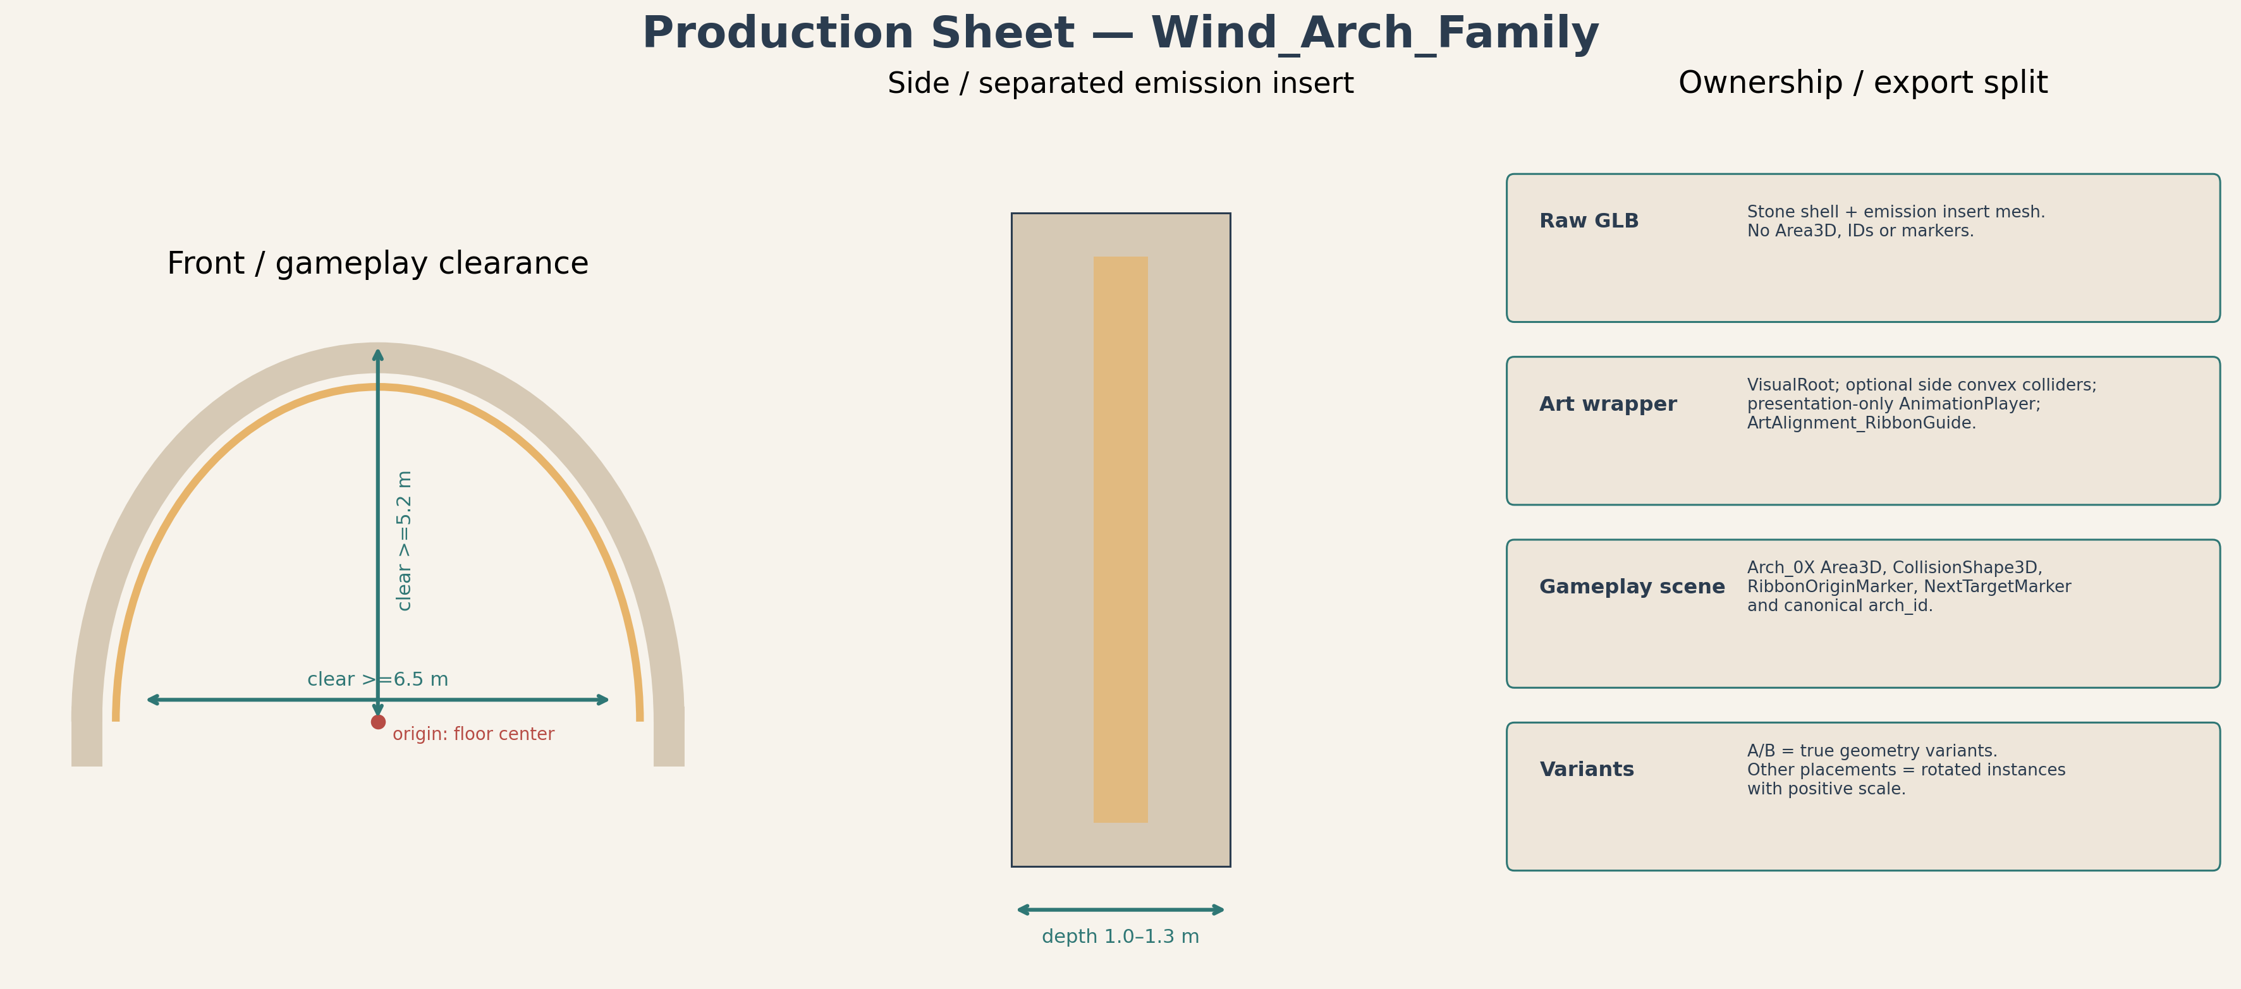
Figure 5. Wind Arch decomposition, origin, clear opening and ownership split.
• Frame and emission insert export separately or as clearly separated mesh objects/material slots.
• Mesh origin is floor-center between supports. Gameplay crossing Area3D and IDs remain external.
• Authoritative RibbonOrigin and NextTarget markers remain in WindTrace gameplay scene. Art may provide only ArtAlignment_Ribbon guidance.
• Support collision is optional and simple; it cannot reduce the 6.5 m clear width or 5.2 m overhead clearance.
• A and B are explicit positive-scale variants. Do not use negative-scale mirroring.

8.3 SeedPod_Perch_Family and Playful Spark production sheet
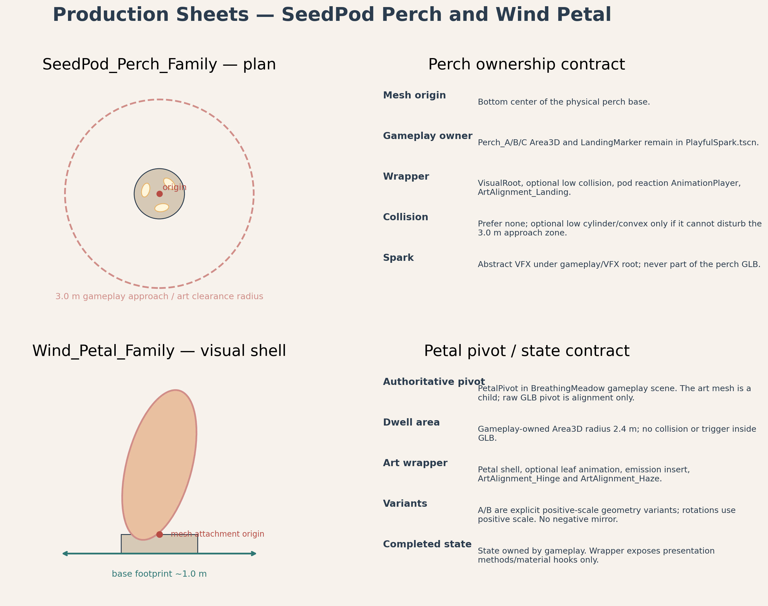
Figure 6. Perch and wind-petal visual decomposition with gameplay-owned landing/pivot contracts.
Component | Art responsibility | Gameplay authority retained outside art
Perch base | Readable low landing/reaction support and optional simple static collision | Approach Area3D, current sequence ID, LandingMarker and occupancy semantics
Seed-pod cluster | Warm reaction/opening presentation; separable emissive parts if practical | Sequence completion, preglow timing and Shard_06 reveal
Spark impulse VFX | Abstract warm light point/trail with no face, eyes, wings or mascot behavior | A→B→C ordering, hop terminal/fallback and destination selection

8.4 Wind_Petal_Family and Rest Point production sheet
Component | Production contract
Petal base | Static visual socket centered at the gameplay target. No dwell Area3D in GLB.
Petal leaf | Independent mesh with attachment-point origin. Gameplay-owned PetalPivot controls any presentation transform.
Variants | A/B explicit geometry variants; three placed instances use positive scale and may rotate.
Rest Point dais | Low center composition, Ø3.2 m target. Does not become a shrine or raised altar.
Progress segments | Three identical or explicit arc inserts; display-only, independently addressable by wrapper/material, state owned by gameplay.
Haze binding | No fog volume inside GLB. EnvironmentStateRoot owns LocalHaze_W/SE/NE.

8.5 Final Overlook composition sheet
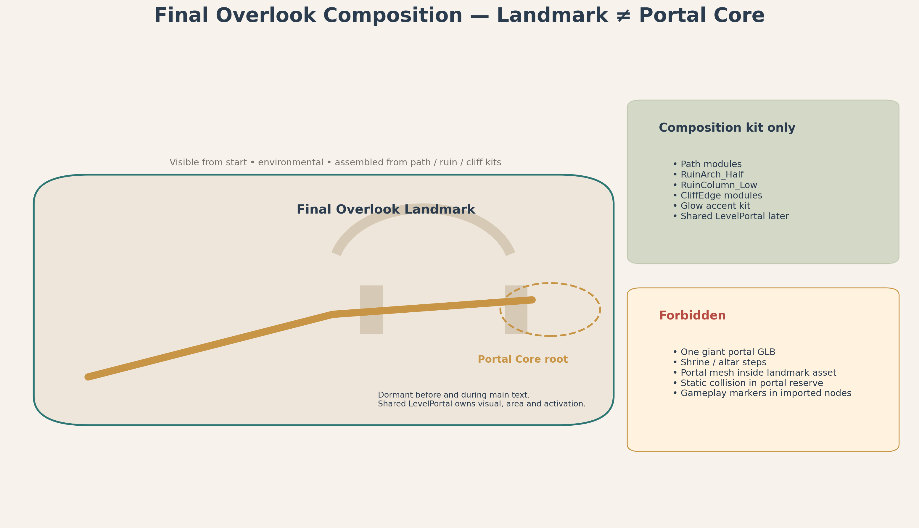
Figure 7. Final Overlook is a modular environmental landmark. Portal Core remains a separate shared gameplay-owned scene.
• Final Overlook Landmark is visible from the beginning as the clearest distant silhouette. It is not an active portal frame.
• The composition uses path, ruin, cliff-edge and glow-accent kits. It is not a new hero asset family and does not require a monolithic GLB.
• LevelPortalRoot / PortalFloorAnchor at (10.0, 1.6, 50.5) remains authoritative and external to all art GLBs.
• The shared LevelPortal footprint stays clear. Level_03 local PortalAccentVFX begins only after main text and never fabricates shared activation state.
• The horizon remains open. No altar stair, shrine axis, trophy pedestal or giant destination portal.

9. Collision matrix
Element | Owner | Recommended collision | Required? | Acceptance rule
Walkable zone blocks | StaticBody3D in block/wrapper | Simplified custom floor proxy | Required | Matches approved floor; no holes >0.10 m; cross-slope <=3°.
Path modules | StaticBody3D | Simple custom/box blend | Required | Continuous seams; step <=0.15 m; slope limits preserved.
Hard boundary belt | Godot-owned gameplay collision | Boxes/convex strips following edge | Required | Behind visible rim; no route opening obstruction.
Visible cliff/edge art | Art wrapper | Usually none | Optional | Never relied on as sole fall prevention.
Wind arch supports | Art wrapper | Simple convex per support | Optional | No central collision; clear W/H maintained.
Perch base | Art wrapper | Low convex or none | Optional | Cannot impede 3 m approach clearance.
Seed-pods | Art wrapper | None | No | Presentation only.
Wind petal leaf/base | Art wrapper | None or tiny static base only | Prefer none | Dwell Area3D and pivot remain gameplay-owned.
Rest Point dais | Art wrapper | Low cylinder/custom | Optional | No raised step >0.15 m.
Ruin modules | Art wrapper | Simple box/convex if player-facing | Selective | Avoid complex mesh collision.
Major tree trunk | Art wrapper | Simple capsule/box | Selective | Only outside camera corridor and puzzle clearances.
Small foliage/debris | Art wrapper | None | No | Must not block route.
SoftReturn / OOB | Gameplay SafetyRoot | Area3D volumes | Required | No physical catch collision.
Portal | Shared LevelPortal | Shared InteractionArea/shape | Required / shared | No custom duplicate collision or trigger.
Moving/presentation meshes | VFX/art wrapper | None | No | No trimesh moving collision.

10. Pivot, origin and marker contracts
Asset type | Raw mesh origin | Purpose | Authoritative gameplay counterpart
Static block base | Zone center on authored floor plane | Placement and art swap | World zone coordinates / block wrapper owns placement
Path straight/curve/ramp | Documented seam center; tangent/forward recorded | Seam assembly | Gameplay centerline remains external authority
Cliff/edge module | Inner top seam center | Align visible rim | Hard boundary collision external
Wind arch frame | Floor-center between supports; local authored forward -Y in Blender | Placement and positive-scale rotation | Arch crossing Area3D, RibbonOrigin and NextTarget external
Perch base / seed-pod | Bottom-center at support contact | Presentation placement | LandingMarker and approach Area3D external
Wind petal leaf | Physical attachment point at petal root | Visual drift/open animation | Authoritative PetalPivot external
Rest Point dais | Center on ground | Composition placement | ConvergenceMarker and progress facts external
Shard platform | Center on ground beneath shard | Visual support | ShardAnchor external
Ruin / tree | Bottom-center or documented seam | Placement / modular assembly | No gameplay target embedded
Final Overlook composition | Wrapper origin at (6,1.6,47) composition center | Assemble modular kit | Main_Text_Gate and LevelPortalRoot external

Marker naming
Art wrappers may expose non-authoritative alignment aids only, prefixed ArtAlignment_. Examples: ArtAlignment_Ribbon, ArtAlignment_SeedPodAttach and ArtAlignment_PetalAttach. Gameplay scenes do not bind progression to imported GLB child names.

11. Wrapper-first Blender → GLB → Godot pipeline
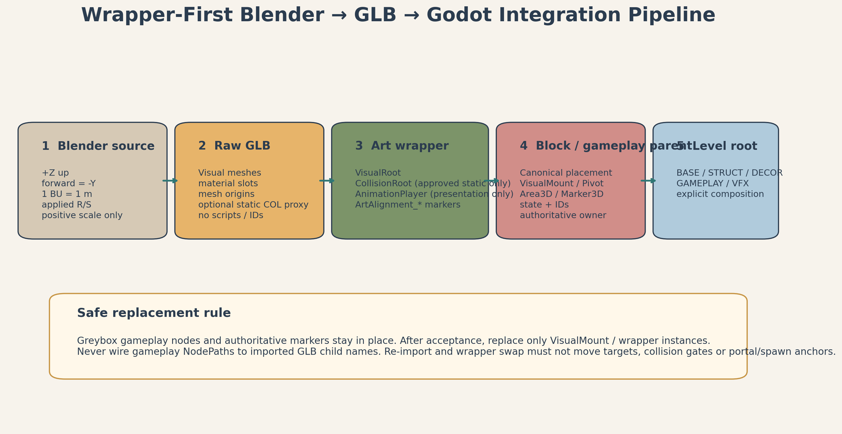
Figure 8. Wrapper-first pipeline and authority boundary.
1. Author in Blender: Model one canonical asset family/component at metric scale. Keep material slots minimal and separate any maskable emission surface.
2. Validate source: Apply transforms; confirm +Z up, authored -Y forward, positive scale, documented origin and no hidden/unused production objects.
3. Export raw GLB: Use standard glTF 2.0. Export visual mesh only plus optional explicit _COL asset when a custom collision proxy is justified.
4. Godot import test: Open in an isolated import verification scene. Confirm scale, +Y up/-Z forward result, origin, ground contact, slots and warnings.
5. Create art wrapper: Wrapper contains VisualRoot, raw GLB instance, approved static collision, optional presentation-only AnimationPlayer and ArtAlignment_* markers.
6. Integrate into block/gameplay parent: Parent scene owns placement and all gameplay references. Wrapper remains replaceable and receives presentation calls only.
7. Primitive swap: Replace only the primitive under an existing VisualMount/Block wrapper; keep gameplay Area3D, pivots, markers, NodePaths and IDs unchanged.
8. Acceptance regression: Re-run traversal, clearances, camera QA, puzzle readability, missing-VFX fallback and performance checks.

11.1 Wrapper content contract
Wrapper may contain | Wrapper must not contain
Raw GLB visual instance | Canonical gameplay ID or puzzle order
Approved StaticBody3D/CollisionShape3D for environmental geometry | Area3D interaction/dwell/crossing triggers
Material overrides / scene-local duplicated materials | Shard spawn/reveal ownership
Presentation-only AnimationPlayer | Authoritative RotationPivot / PetalPivot / LandingMarker / Beam targets
ArtAlignment_* markers | Level progression, reward, portal or recovery scripts
Visibility / LOD / culling configuration | Critical NodePaths into imported child hierarchy

12. IMMEDIATE GREYBOX HANDOFF
AUTHORIZED CONTENT OF A FUTURE GREYBOX DEVELOPMENT REFERENCE
Only dimensions, coordinates, proxy shapes, collision policy, layer boundaries, gameplay-owned pivot/marker contracts and acceptance criteria from this Bible may flow into the future Greybox Development Reference. This Bible itself does not authorize implementation.

May be consumed immediately after Producer approval | Must remain deferred
P00–P16 route coordinates and all locked gameplay anchors | Final Blender models and GLBs
Zone footprints, floor elevations, route widths and slopes | Final textures and material authoring
Primitive platform/path/blocker shapes | Godot art wrappers for production meshes
Hard boundary belt, SoftReturn/OOB policy and RA0–RA6 anchors | Final foliage, ruin dressing and background silhouettes
Arch/perch/petal proxy dimensions and 3 m clearances | Polished ribbon/spark/petal/haze VFX
Gameplay-owned pivot/marker placeholders and VisualMount nodes | Final environment lighting/color polish
Portal clearance and shared LevelPortal root anchor | Final portal accent or custom portal visuals
Camera QA points CP0–CP4 and sightline gates | Optimization based on unapproved art content

12.1 Greybox acceptance preconditions before art swap
• Full route traversable with no mandatory jump, gap or abrupt step; floor profile matches the approved spec.
• Minimum route, shoulder, camera and puzzle clearances pass at all beats.
• All three arches, perches and petals are readable with primitive proxies and approved third-person camera.
• Hard boundaries and explicit SoftReturn/OOB recovery pass without invisible playable space.
• Shard reward, main-text and shared portal flows pass with primitives and optional VFX disabled.
• All gameplay pivots, markers and triggers live outside art placeholders and remain stable under a dummy visual swap.
• Producer explicitly accepts the greybox before post-greybox art integration begins.

13. POST-GREYBOX ART INTEGRATION SLICES
DO NOT EXECUTE THESE SLICES IN THE INITIAL LEVEL_03 GREYBOX PR.
Each slice begins only after the greybox acceptance gate and should remain small, reviewable and independently reversible.

Slice | Scope | Exit gate
A. Import foundation | Create approved folder structure, import-test scene and wrapper template; document baseline warnings. | One sample asset imports at correct scale/origin; no gameplay tree changes.
B. BASE visual swap | Produce/swap zone blocks and route modules one block at a time. | Traversal and boundary regression pass after each block.
C. Wind Arch family | Produce Frame A/B and emission insert; integrate without moving gameplay triggers. | Three arches retain clear W/H, IDs and hint behavior.
D. SeedPod/Perch family | Produce perch bases, pod clusters and restrained impulse VFX. | A→B→C sequence remains readable; no mascot reading.
E. Wind Petal / Rest Point | Produce petal base/leaf variants, dais and segments. | All targets visible; proximity dwell and all six orders pass.
F. Ruin/cliff/overlook composition | Build modular ruin/cliff kit and assemble Final Overlook landmark. | No shrine/arena reading; portal footprint and horizon stay clear.
G. DECOR pass | Trees, rocks, roots, grass, flowers, vines and distant silhouettes. | Route/camera/puzzle exclusion zones remain clean.
H. Material/state integration | Author shared families and scene-local tintable instances for E0–E6. | No shared-resource mutation; E0 color visibly alive.
I. VFX integration | Ribbons, grass response, spark, petal preglow, local haze, synthesis and portal accent. | Presentation removal cannot block progression; fallbacks pass.
J. Optimization and acceptance | LOD/culling, collision simplification, import warnings, visual QA and performance evidence. | All art gates and 60 FPS target evidence pass on agreed baseline.

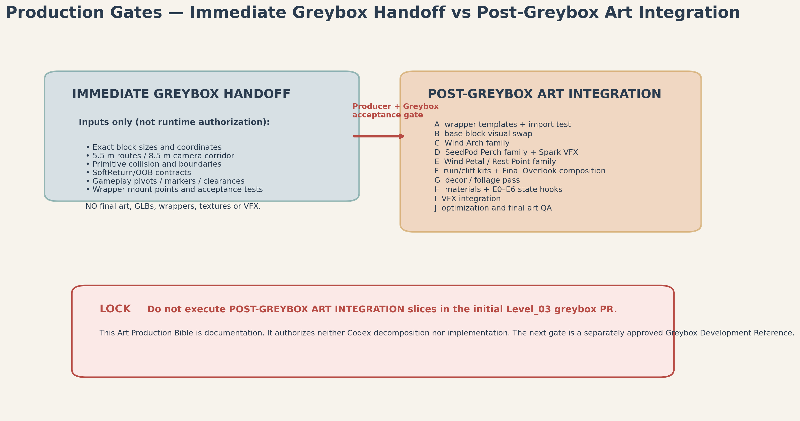
Figure 9. Production gates: documentation → greybox acceptance → controlled art integration → final acceptance.

14. Production priority
Priority | Content | Reason
P0 - Greybox-critical | Zone dimensions, route proxies, boundary belt, SoftReturn/OOB, clearances, portal floor anchor, gameplay pivot/marker placeholders. | Required to prove the level works before art.
P1 - Gameplay-critical visual families | Wind Arch A, perch base/seed-pod cluster, wind-petal base/leaf, Rest Point and shard support. | These make puzzle rules readable without owning them.
P2 - Visual identity | BASE block visual swaps, ruin/cliff kit, Final Overlook composition, major trees, material/state integration and key VFX. | Creates the approved Level_03 identity after mechanics are accepted.
P3 - Decorative polish | Bushes, grass, flowers, vines, moss, debris, ambient seed-pods, distant silhouettes and secondary VFX. | Removable polish; never blocks shipping or readability.

15. Blender / GLB / Godot export checklist
☐ 1 BU = 1 m; +Z up; authored -Y forward documented.
☐ Location, rotation and scale applied; final scale is positive 1/1/1.
☐ Origin matches the registry contract and ground contact is correct.
☐ No hidden unused objects, duplicate meshes, cameras or lights unless explicitly required.
☐ No unapplied modifier that changes export unexpectedly.
☐ Minimal material slots; emission surfaces separate or maskable where required.
☐ No gameplay script, canonical ID, Area3D, target or state inside raw GLB.
☐ Optional custom collision is a separate simple proxy and never a moving trimesh.
☐ File and object naming follows L03_* rules; explicit variant suffix is unambiguous.
☐ GLB test-imported in Godot; +Y up / -Z forward result, size, materials and warnings verified.
☐ Wrapper scene created only in post-greybox slice; VisualRoot and collision ownership documented.
☐ No negative-scale instance in Blender export or Godot placement.
☐ ArtAlignment_* markers are non-authoritative and optional.
☐ Primitive swap leaves gameplay pivots, Area3D nodes, IDs, NodePaths and portal/recovery ownership untouched.
☐ QA evidence captures route clearance, camera sightlines, puzzle readability and missing-VFX behavior.

16. Art acceptance gates
Gate | Acceptance criterion
A-01 Scale / coordinates | Block seams, arch/perch/petal placement and Final Overlook composition align to authoritative anchors within art tolerance; gameplay targets do not move.
A-02 Traversal | Route never falls below 5.5 m; turns/rewards remain 6–7 m; no mandatory gap/step/jump introduced.
A-03 Camera safety | 8.5 m camera corridor and CP0–CP4 sightlines remain clear; no near-camera foliage wall or tall prop pop-in.
A-04 Puzzle clearance | 3 m clear radius around shards, perches, petals and rest point; all required targets readable from zone entry.
A-05 Boundary integrity | Hard belt remains behind visible rim; all route mouths open; no invisible catch floor or legal-space recovery overlap.
A-06 Ownership | No gameplay state, canonical ID, authoritative marker/pivot, trigger or portal logic inside GLB/art wrapper.
A-07 Silhouette / emotion | Continuous airy S-walk; no hub, arena, shrine, fortress, trophy or dead-world reading.
A-08 Family budget | Only three semi-hero families. Final Overlook and Rest Point are modular compositions.
A-09 Materials | Shared families, no 4K by default, no excessive unique slots, E0 visibly colored and alive.
A-10 Environment phases | E0–E6 visual targets remain non-blocking and local; portal inactive through synthesis/main text.
A-11 VFX compatibility | All presentation nodes removable/disabled without softlock; no over-bloom or audio dependency.
A-12 Import stability | No import errors, invalid resources or fragile child-name dependencies; positive scale everywhere.
A-13 Performance | Agreed 60 FPS target holds on the project baseline after LOD/culling and effects pass.
A-14 Regression | Shard rewards, fall recovery, main text and Level_04 transition still pass after every art swap.

17. Production risks and corrections
Risk | Severity | Mitigation
R-01 Monolithic environment GLB | High | Block-level wrappers and modular families; forbid one giant Level_03 export.
R-02 Art moves gameplay anchors | High | All authoritative markers remain in gameplay scenes; visual swap test required.
R-03 Negative-scale variants | High | Explicit Blender variants with applied mirror; positive-scale instance audit.
R-04 Boundary art creates invisible wall mismatch | High | Visible rim and hard belt reviewed together; openings tested from both directions.
R-05 Decorative clutter hides route or targets | High | Enforce shoulder/camera/puzzle exclusion zones before dressing approval.
R-06 Final Overlook reads as shrine/portal from start | High | Modular environmental silhouette; portal core dormant and visually secondary until main-text close.
R-07 Spark becomes mascot | Medium | Abstract light impulse only; no face, eyes, wings, voice or character poses.
R-08 Materials require unique texture set per asset | Medium | Shared tiling/atlas families; approve exceptions explicitly.
R-09 Environment tween mutates shared material resources | High | Scene-local/deeply duplicated runtime resources; wrapper materials prepared for local override.
R-10 Collision complexity harms movement/performance | High | Simplified custom proxies; no moving trimesh; collision matrix gate.
R-11 Final art enters greybox PR | High | Immediate/deferred gate and explicit post-greybox slice labels.
R-12 VFX softlocks progress | High | VFX owns no progression; controller bounded fallbacks remain authoritative.

18. Handoff boundary
Consumer | Receives from this Bible | Must not infer
Producer | Scope, family budget, production gates, art risks and acceptance criteria | That implementation or final art is authorized.
Greybox Development Reference author | Coordinates, dimensions, proxy shapes, boundary/collision rules, pivot contracts and immediate handoff list | Final meshes, materials, wrappers or post-greybox slices in the initial PR.
Godot Tech | Ownership boundaries, wrapper contracts, collision/pivot rules and art-swap requirements | Any replacement of Technical Architecture NodePaths/state contracts.
Blender / Art | Full registry, dimensions, origins, variants, materials, budgets, paths and export checklist | Gameplay state or target ownership inside GLB.
Codex Task Generator | Only post-approval, stage-appropriate slices; immediate greybox vs deferred art split | A single giant implementation task or cross-stage PR.
QA | Boundary, camera, readability, import, performance and regression gates | That concept images define exact geometry.

Appendix A. Exact production anchors and camera/recovery references
Identity | Vector3 / dimensions | Authority
P00 Spawn centerline | (-6.00, 0.00, -49.00) | Route / block
P01 Inlet exit | (-5.80, 0.08, -43.00) | Route
P02 Arch_01 | (-5.50, 0.15, -40.50) | Route / gameplay
P03 Curve east | (1.00, 0.35, -35.00) | Route
P04 Arch_02 | (2.00, 0.45, -32.00) | Route / gameplay
P05 Curve west | (-1.00, 0.65, -27.00) | Route
P06 Arch_03 | (-3.50, 0.80, -23.50) | Route / gameplay
P07 Shard05 overlook | (-8.00, 0.90, -16.00) | Route / block
P08 Glade approach | (-1.00, 0.95, -9.00) | Route
P09 Playful Glade center | (7.00, 1.00, -3.00) | Route / block
P10 Glade exit | (4.00, 1.05, 7.00) | Route
P11 Exhale bend | (-1.00, 1.15, 13.00) | Route
P12 Meadow entry | (-4.00, 1.28, 18.00) | Route
P13 Meadow center | (-7.00, 1.30, 28.50) | Route / block
P14 Final approach | (-1.50, 1.45, 38.00) | Route
P15 Final Overlook | (6.00, 1.60, 47.00) | Route / block
P16 LevelPortalRoot | (10.00, 1.60, 50.50) | Shared portal floor anchor
Shard_05 | (-8.00, 2.00, -15.00) | Gameplay anchor
Perch_A | (1.50, 1.05, -7.00) | Gameplay anchor
Perch_B | (10.50, 1.05, -3.00) | Gameplay anchor
Perch_C | (4.00, 1.05, 3.00) | Gameplay anchor
Shard_06 | (4.00, 2.00, 4.20) | Gameplay anchor
Petal_W | (-16.00, 1.30, 27.00) | Gameplay anchor
Petal_SE | (-4.00, 1.30, 21.50) | Gameplay anchor
Petal_NE | (-1.50, 1.35, 34.00) | Gameplay anchor
Rest_Point / Shard_07 | (-7.00, 1.30 / 2.20, 28.50) | Gameplay anchor
Main_Text_Gate | (6.00, 1.60, 47.00), R4.5 | Gameplay gate

Appendix B. Camera QA and recovery anchors
Reference | Position / target | Art/QA rule
CP0 Arrival | (-9,5.5,-44) → look at (6,2.5,47) | Final Overlook silhouette readable; portal not dominant
CP1 Shard05 | (-10,5,-18) → look at (7,1,-3) | Playful Glade preview
CP2 Glade | (1,6,-9) → look at (7,1,-3) | All three perches in one composition
CP3 Meadow | (-3,7,18) → look at (-7,1.3,28.5) | All three petals and Rest Point readable
CP4 Final | (0,6,41) → look at (6,1.6,47) | Final landmark/horizon and dormant portal floor setting
RA0 | (-6,.65,-49) | Guaranteed fallback
RA1 | (-4.5,.95,-20) | Wind Trace milestone
RA2 | (-8,1,-16) | Shard05 overlook
RA3 | (4,1.1,7) | Glade exit
RA4 | (-4,1.35,18) | Meadow entry
RA5 | (-7,1.4,28.5) | Meadow center
RA6 | (6,1.7,46) | Final approach

Appendix C. Visual authority references
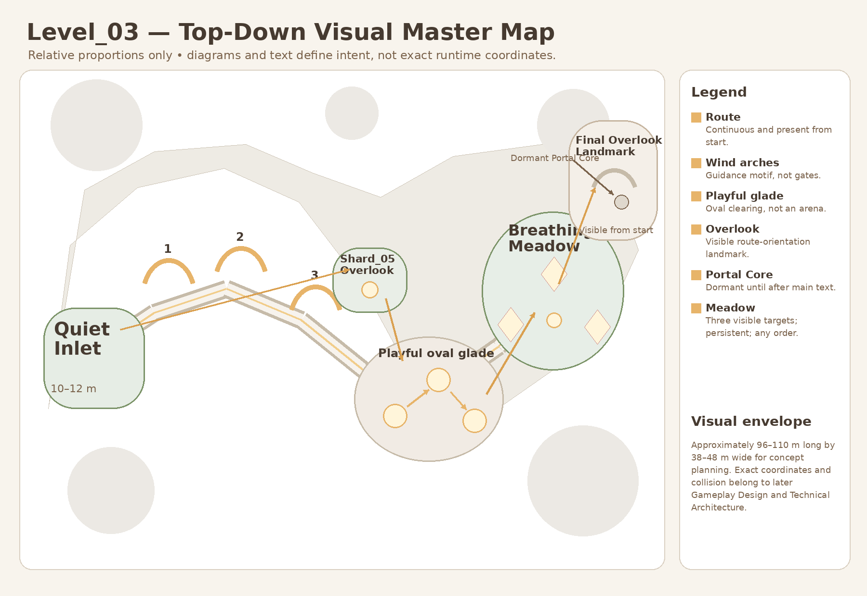
Approved Level_03 top-down visual reference. The exact Gameplay Spec coordinates and Boundary Map in this Bible take precedence for production geometry.
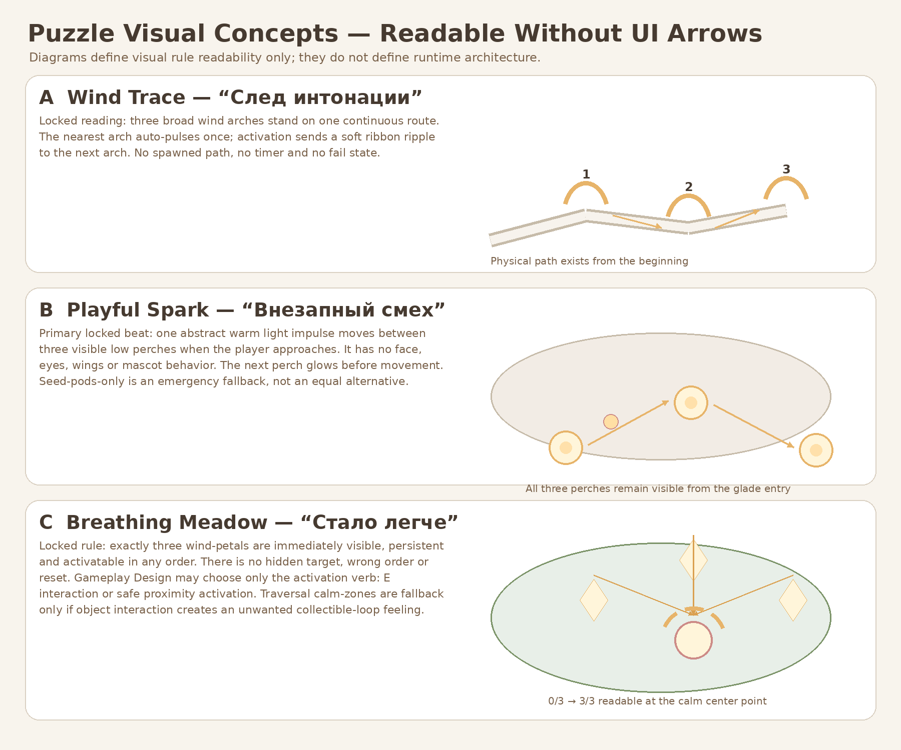
Approved puzzle-readability reference. Production sheets and gameplay-owned marker contracts in this Bible define the integration boundary.
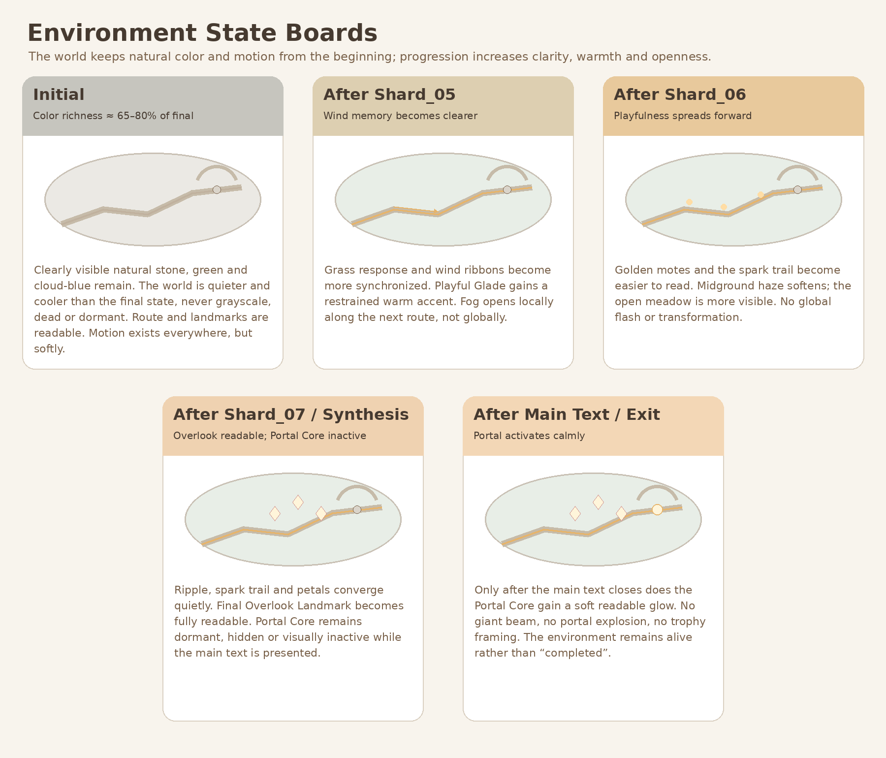
Approved environment-state reference. Materials and VFX must support these states without owning progression.
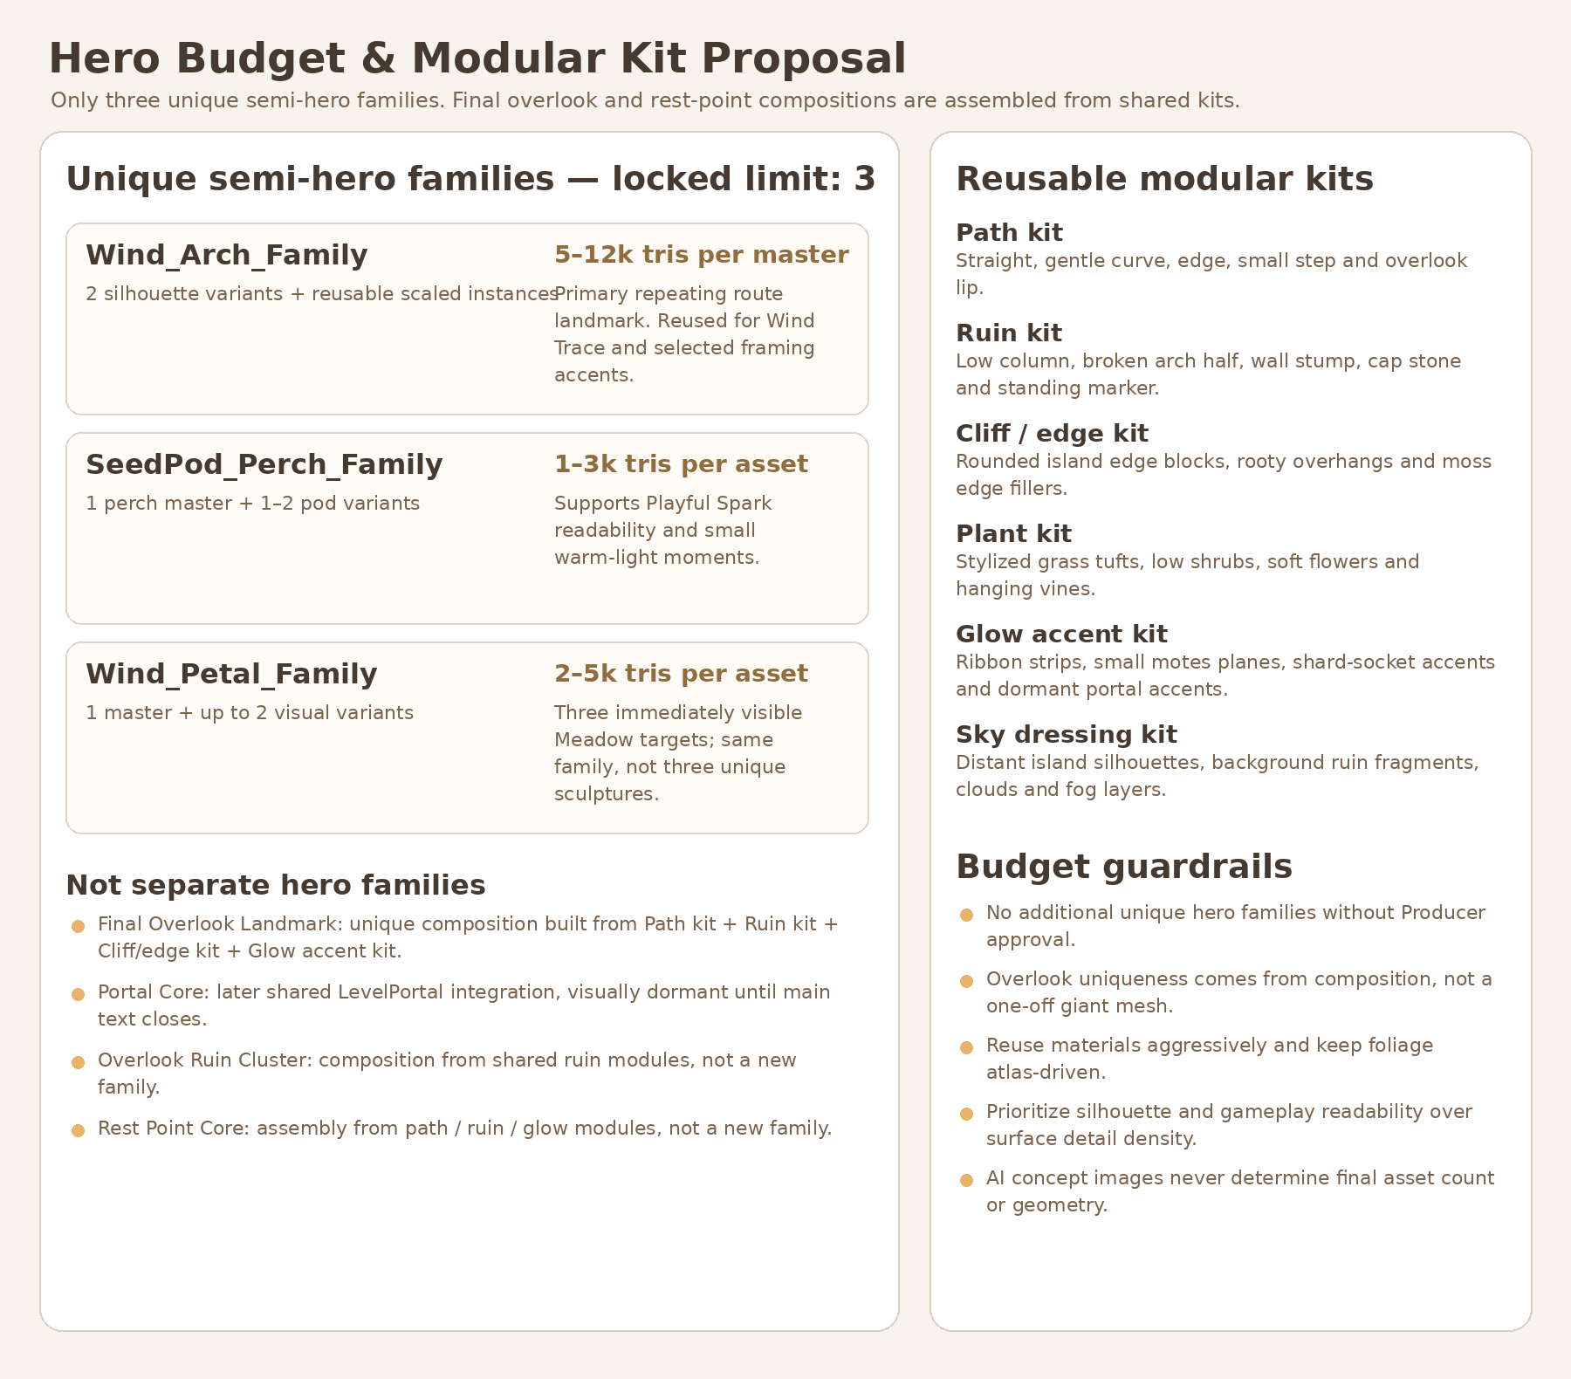
Approved semi-hero/modular budget direction. This Bible locks the registry and removes Final Overlook/Rest Point as separate hero families.

Document completion statement
COMPLETE
This document is the self-contained Art Production Bible candidate for Level_03. It defines boundaries, layer ownership, registry, dimensions, origins, pivot contracts, collision policy, Blender/GLB/Godot workflow, production gates and post-greybox slices. It creates no runtime or art assets and does not authorize an implementation PR.

